Self-Balancing Robot (Inverted Pendulum on Wheels)
IDEA
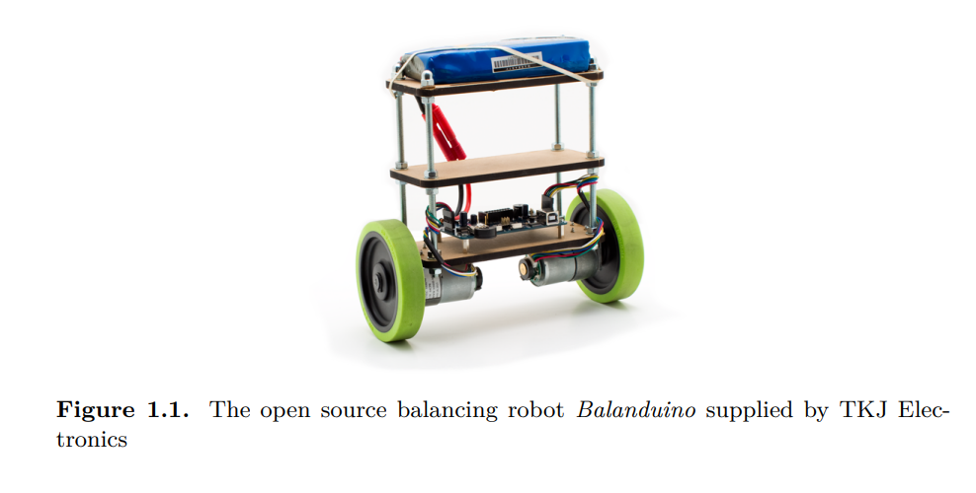
How it works
- An IMU sensor (accelerometer + gyroscope) measures the robot’s tilt angle
- A Kalman filter (or complementary filter) fuses the sensor data for a clean angle estimate
- A PID controller computes motor corrections in real time to keep it balanced
- Two DC motors with encoders drive the wheels accordingly
- (Optional) Full LQR state-space controller
Suggested Stack
Component | Suggested Part | Approximate Cost
Microcontroller | Arduino | R80 – R150
IMU | MPU-6050 (6-axis) | R60 - R100
Motor Driver | L298N Dual H-Bridge | R60 - R90
DC Gear Motors (x2) | With encoders, 6V-12V | R200 – R400
Wheels (x2) | 65 mm rubber wheels | R60 – R120
Chassis | Laser-cut acrylic or 3D printed | R150 – R300
Battery | 2S LiPo or 4x AA pack | R100 – R200
Misc. (wiring, standoffs, switches) | --- | R100 – R150
Total |  | ~R810 – R1510

Leaving room to add Raspberry Pi for data logging, a Bluetooth module for tuning PID gains wirelessly, or even an LCD to display live sensor values.
Where to buy
- Micro Robotics (Stellenbosch)
- Communica (Paarden Eiland)
- RS Components SA (Online)
- DigiKey South Africa (Online)
Milestones
- Get the IMU reading – wire up the MPU-6050, read raw data, implement a complementary filter to get a clean tilt angle.
- Drive the motors – test the H-bridge, get basic forward/back working
- Close the loop – implement a basic P controller first, observe instability, then add I and D terms
- Tune the PID – this is where the fun (and frustration!) is
- Stretch goal – implement an LQR controller and compare performance to PID
External Links
- https://www.instructables.com/Self-Balancing-Upside-Down-Pendulum/
- https://www.shaysackett.com/inverted-pendulum-robot/
- https://www.diva-portal.org/smash/get/diva2:916184/FULLTEXT01.pdf
- https://youtu.be/jP7Y_BfuGDI?si=Myiii08xSY3t1dM1 - Balancing robot tips video.
Objectives
- Get it to balance “horizontally”.
- Get it to balance “vertically”.
- Implement cascaded PID loop (velocity = 0).
- Try to implement LQR?
VERSION HISTORY
Idea is to do a prototype with version 2 and then upgrade the motors to version 3.
Version | Description of Change
v1 | First draft

VERSION 1
COMPONENTS
MPU-6050
- https://youtu.be/rpCcZZJeodY?si=zEn9Rm8-psDM20C_ - YouTube video.
- https://forum.arduino.cc/t/getting-started-with-the-mpu6050-beginner-friendly-guide-with-visual-explanations/1364064 - Arduino forum explanation (other useful links).
- https://www.electronicwings.com/sensors-modules/mpu6050-gyroscope-accelerometer-temperature-sensor-module - Communica link.
Arduino
- Nano or Mega (probably Mega as it will make a better body “shape”). Going to use Uno (correct size and I am familiar with it).
Motor Driver
- L298N Dual H-Bridge.
- https://youtu.be/1bxwINoBz8M?si=n8Yrparx3H1zSFY7.
- OR L293D (smaller, cheaper).
- https://youtu.be/KKoduge9V50?si=kxc7bmY12_8Xtdx- - How to use L293D (1xDC motor per side).
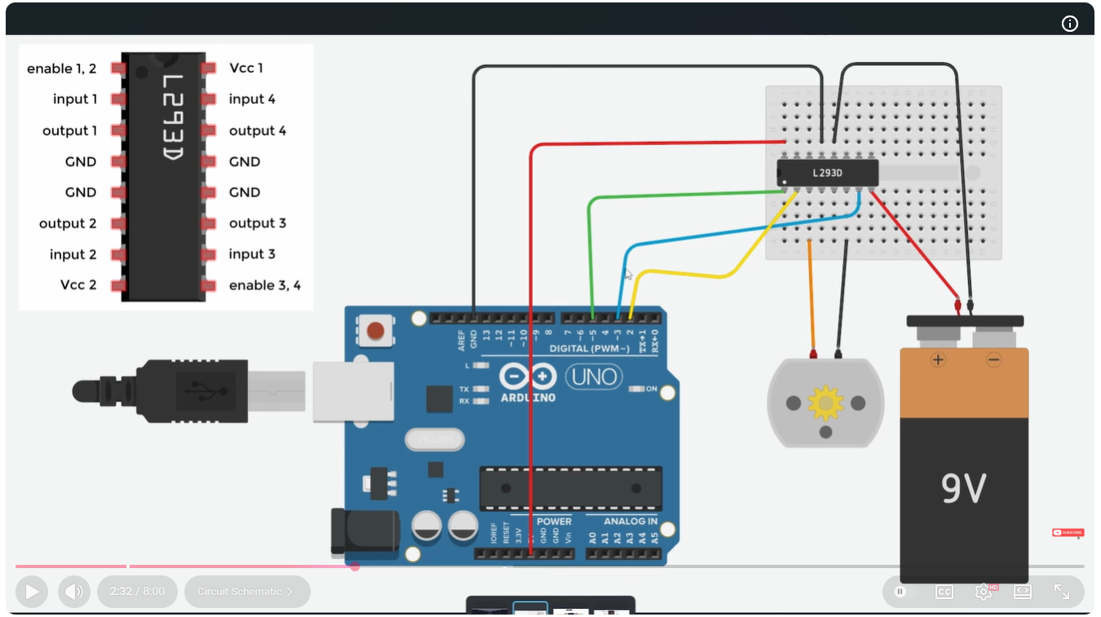
- Pin explanation:
Pin | Purpose
Enable 1,2 | Controls speed of motor 1 (PWM signal - analogueWrite)
Input 1 and Input 2 | Set one high and one low to control motor 1 direction (digitalWrite)
Output 1 and Output 2 | Connects to motor 1
GND | Ground (must ground to Arduino ground and battery-)
VCC 2 | Connect to positive terminal of battery
VCC 1 | Powers L293D driver (5V)
Input 3 and Input 4 | Set one high and one low to control motor 2 direction
Output 3 and Output 4 | Connects to motor 2
Enable 3,4 | Controls speed of motor 2 (PWM signal - analogueWrite)

DC Gear Motors (x2)
- https://youtu.be/GPVC84D5ULw?si=AKUwRgfWL-u2UtGY.
- What motors to use? – Tips video uses standard yellow motors (see below) with L293D motor drivers.
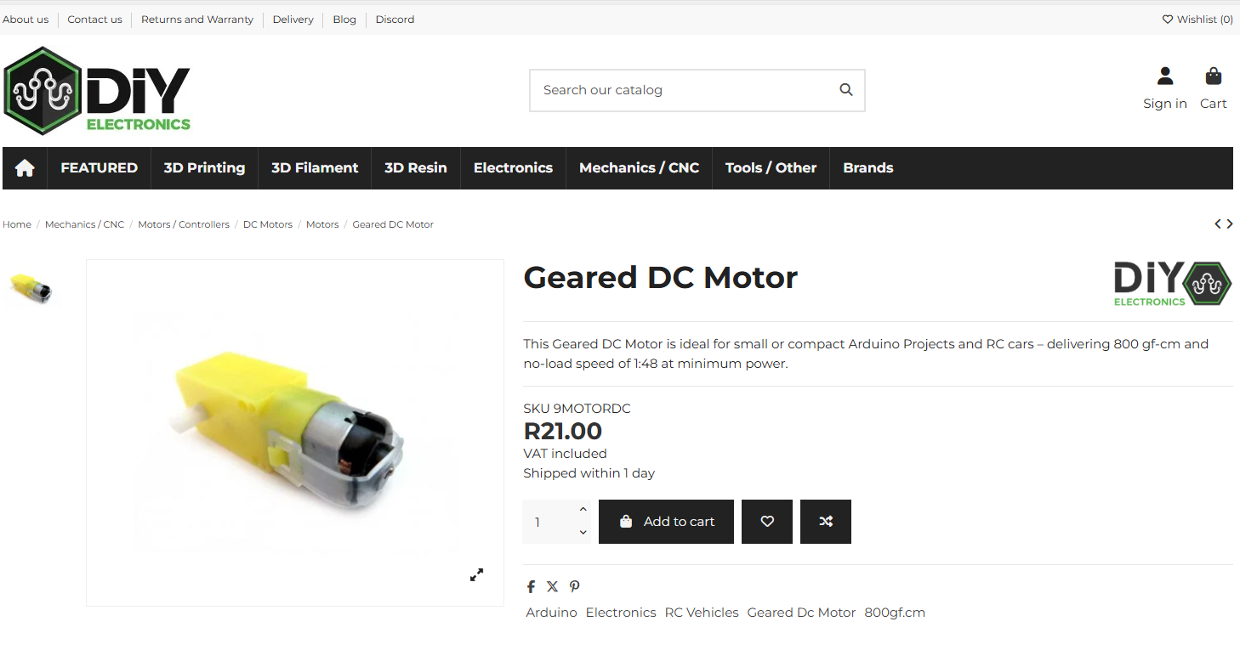
Wheels
- Standard wheels we used for Micromouse (see below).
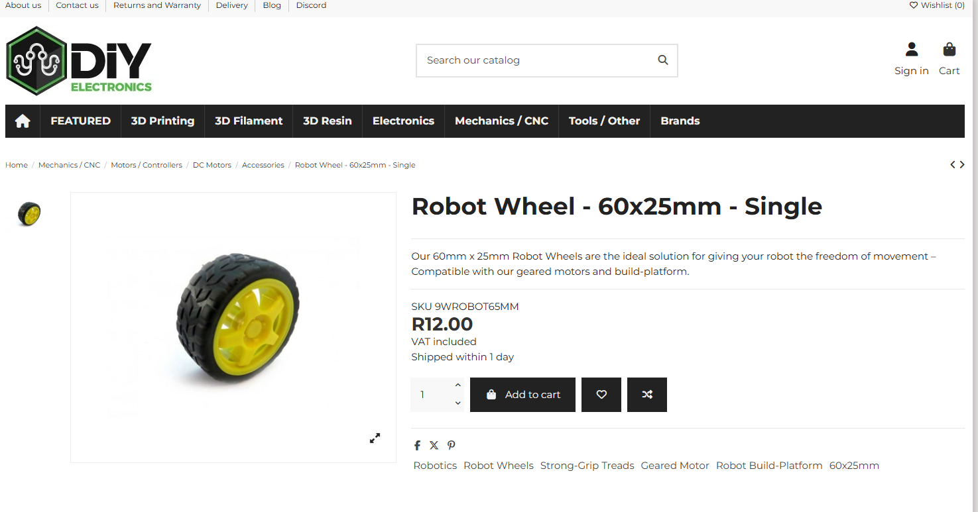
Chassis
- 3D print?
- Use breadboard?
- Will try and use breadboard and Arduino together directly connected to motors. Possibly both need to be put on small wooden board.
Battery
- Can power from laptop to start?
- https://www.robotics.org.za/503759 - Too low voltage.
- Look at micro mouse project for battery charging circuit with switch (maybe I don’t need a switch).
- https://www.robotics.org.za/603450 - 7.4V battery.
- Will need a charging circuit too.
- https://www.robotics.org.za/DFR0564 - Battery charger circuit (USB).
- Do I need JST PH connector to connect to breadboard (something like below)? I think so.
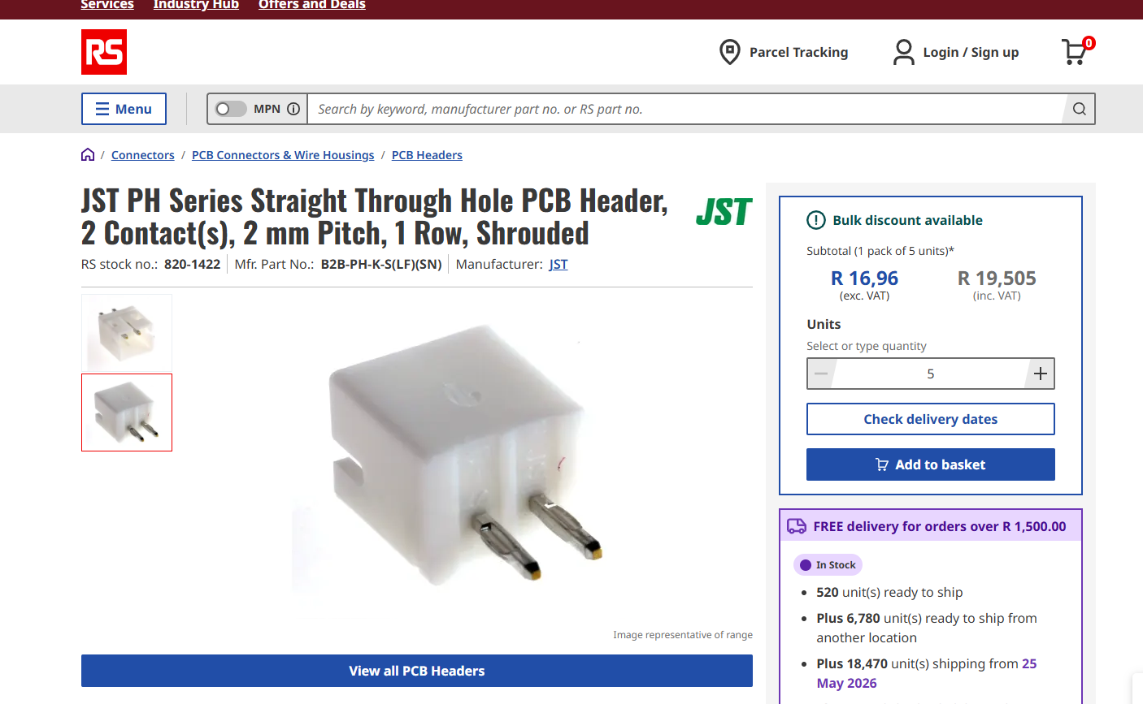
- https://www.communica.co.za/products/xy132-02st - Communica version.
Other
- Nice small breadboard with multiple dividers? See below link.
- https://www.communica.co.za/products/bmt-breadboard-8-3x5-5cm-400tp?variant=52114451857708&sfdr_ptcid=31591_617_756176052&sfdr_hash=bb756a0b0dccbe2ed9b1a7c65af875e6&utm_source=www.communica.co.za&gad_source=1&gad_campaignid=20668254388&gbraid=0AAAAADLTnIbzvEAdrt-ixEG3Gu6-UzOf6&gclid=CjwKCAjw8arQBhB9EiwAfIKdQkSSMzc7uims97IhZc9b69lC9DkFK7bfecUCEdPY-fcZT8k1Mxqk8hoCdSUQAvD_BwE.
- Nice connectors.
SCHEMATIC / CONNECTION DIAGRAM
- Table and diagrams here to track how many pins I need / what is connected to what.
Component | Connects To
MPU-6050
VCC | Arduino 5V
GND | Arduino GND
SCL | Arduino SCL
SDA | Arduino SDA
L293D
Enable 1,2 | Digital Pin 5 Arduino
Input 1 | Digital Pin 2 Arduino
Output 1 | Motor1+
GND | ---
GND | ---
Output 2 | Motor1-
Input 2 | Digital Pin 3 Arduino
VCC 2 | Battery+
VCC 1 | 5V Pin Arduino
Input 4 | Digital Pin Arduino
Output 4 | Motor2+
GND | GND Arduino
GND | Battery-
Output 3 | Motor2-
Input 3 | Digital Pin Arduino
Enable 3,4 | Digital Pin Arduino
Arduino Uno has 14 digital pins (labelled 0 to 13). This should be plenty.
VOLTAGE ANALYSIS

Device | Voltage
Battery Output | 7.4 V
Arduino Voltage Input | 7 V to 12 V (Vin Pin)
Arduino Digital Output Pins | 5 V
Motor Driver Power | 4.5 V to 36 V
Motor Driver Enable | 5 V
DC Motors | 3 V to 6 V
Motor Driver Output | VCC2 -1.4 V = 7.4 V -1.4 V = 6 V
MPU6050 Voltage Supply | 3 V to 5 V
** Voltage just in range (top end) for motors
Device | Current
DC Motors @6V no-load | 160 mA
Driver Continuous Current Limit | 600 mA
DC Motors @6V when stalled | 1.5 A
Driver Peak Current Limit | 1.2 A (for 100 uS)
** Peak current is exceeded but as long as the motors aren’t stalled this shouldn’t be a problem (also that tips and tricks video recommended this set up)
BILL OF MATERIALS

Component | Price | Quantity | Total | Link
Arduino Uno | R125.01 | 1 | R125.01 | Communica – Does it come with cable?
Breadboard | R15 | 1 | R15 | Communica
MPU6050 | R60 | 1 | R60 | Communica
JST-Connector | R0.4 | 3 | R1.2 | Communica
Female Header | R3.39 | 2 | R6.78 | Communica
L293D | R144.96 | 1 | R144.96 | DigiKey
Geared DC Motor | R48.26 | 2 | R97 | Digikey
Robot Wheel | R73.62 | 1 | R74 | DigiKey
Male Connectors | R31.90 | 1 | R31.90 | DigiKey
Battery | R129 | 1 | R129 | Microrobotics
Battery Charger | R109 | 1 | R109 | Microrobotics
Total |  |  | R793.85

SOFTWARE
Kalman Filter
- https://youtu.be/DQw4cNx9wdw?si=WBi8i-YrmZRtg9gD - Kalman Filter Video.
Control Algorithm
A
QUESTIONS
- Does Arduino come with cable? Phone and ask.
- Ask Claude if my planned set up will work – Only potential issue is RPM range of current motors (200 rpm). Most successful projects use higher speed motors (e.g. 300 to 500 rpm range). Shouldn’t be impossible but will make PID tunning more difficult (Tips and tricks video uses this motor).

